Contract number - Ref. [CBA9728682]
life status on the joint and removing joint date of death
Issue description: This is a joint life annuity the first life died first ( 31/07/2020) and the second life died second (08/07/2021).
The death coding was done for the second life and afterward we received the death certificate of the first life.
Arrear payments from 01/10/2020 to 01/07/2021 is still due to the second life’s estate. Please advise if we can proceed with the death coding of the first life and if a fix can be done to remove the death coding of the second life.
*************************************************************************************

Resolution to place transaction along with batch cycle : for example
IPS.PO0144G1.KLB.SRTTRX.D270525
To test the transaction and update above file follow below steps.
XMIT The latest generation of SRTTRX file in TSOA
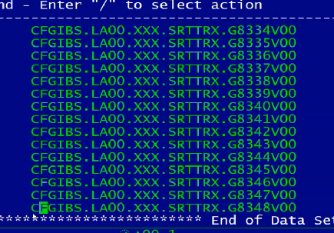
Create test file : We always want to have policy number grater than the policy what we wanted to test
Delete extra policies , remember to take header and footer and 1 or 2 policy grater than the policy we want to test and few more policies.
Save the files.
Now we want to download the data for test policy and policy present on above files.
Copy policy details from test file to below file, and delete header footer

Run below job to initialize all SIBS files. We need to submit it as is.

Next is to unload policy data
Update policy details in row number 66
Submit the job
Now run below job to load the data in sibs

Update input file in row number 91 and 92
Now go into life DUPD OPTION 2

Policy is cease
To update the SRTTRX file repeat any GR transaction row and update test policy and update BATCH
Press F11 and update today’s date
Now update correct code -> to find it check RPS Info sheet and check for annuity level joint life code 0340 then L
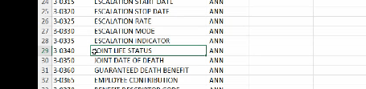
Update code and repeat the roe to remove date of death
First update the sequence number
1 than 2
Than update the date of death removal code 0350 than blank
Updated code will be look like below
Now to test against SIBS run ABCD350S

Update job with SRTTRX file and submit the job.

Now go and verify AUAD file it transaction is accepted
Update WR database -> update WRNUM2 with policy detail than submit the job

Now go into SIBS -> MISC ->1 -> UTE -> UTIL-> OFF -> PF3 -> SHIFT+F3
Run on command line -> CLIST ANNC
Menu
Option 7 -> off again -> enter
<DUPD -> OPTION 2
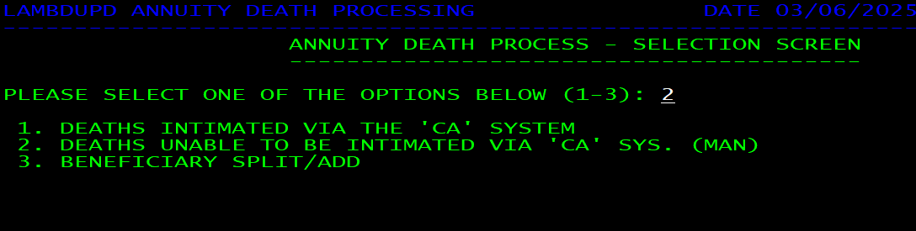
Now take Clint id fro RGG1 screen and date of death from rgg4

Date of death( 1st joint) 24/09/2022

After successful testing this case XMIT The file in tsob and copy the 2 line of transaction onto SRTTRX file

